Bowling Green State University Athletics-Advertising Checklist

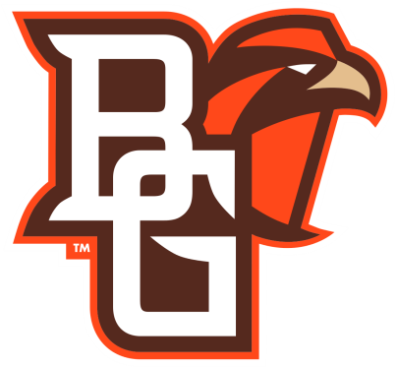

Men’s Soccer Checklist vs. ____________

Two Weeks out/Leading up to game
Make flyers/ Get Approval
Write Campus Updates
Dorm visits to inform about big games (ex. Ohio State, Dayton)
Send out reminder via campus email (Looking ahead Calendar)
Email Clubs to come to game (Ex. Valentis, ESSL Arsenal, Local High Schools)
Ensure that all promotional gear is being printed/delivered

five days out/Leading up to game
Distribute flyers to campus and businesses (See Distribution List)
Follow-up with clubs about coming to the game (Ex. Valentis, ESSL Arsenal, Local High Schools)
Add additional marketing material (posters, flyers, etc.)
Contact groups in participation to make sure they will be there still (Halftime Entertainment; ex. High Flyers, Bubble Soccer, Youth Soccer, Quidditch)
Appropriate Social Media Posts (Screech Team, Twitter, Facebook)
Facebook
Snapchat
Twitter (Screech Team, BGAthletics, ect.)
Instagram
Union table advertising
Coordinate with Falcon Fanatics/ BGSU Bands
Post information on Classroom and Hallway Whiteboards

Day of Game Advertisements
Post social media reminders with promotional items displayed in images
Union Table/Visit Union during lunch
Set-up Marketing Table/Rosters for the game
Place any advertisements up in and around the field

Sport Lead:___________________________ Date:__________________

